Case Study 1:
Create table as below.

Table: Cinema

id Movie_name Actor year Minutes

1 Dharbar Rajini 2021 121
2 Vikram Kamal 2023 125
3 Mersal Vijay 2020 123
4 Beast Vijay 2019 134
5 Viswasam Ajith 2021 117
6 Attakasam Ajith 2006 119
7 Jai Bhim Surya 2018 127
8 Kaithi Karthi 2017 125
9 Ayothi Sasikumar 2023 124
10 Deivathirumagan Vikram 2017 121

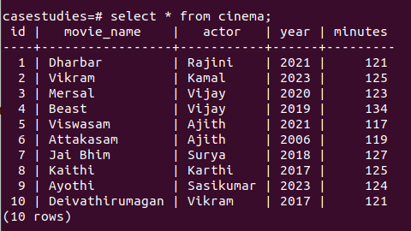

Exercise:
1) List down all the movies from the year 2018

QUERY : select Movie_name , year from cinema where year>2017 order by year;
OUTPUT :

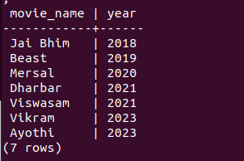

2) List down all the movies where their minutes greater than 120

QUERY : select Movie_name, minutes from cinema where minutes > 120 order by minutes;
OUTPUT :

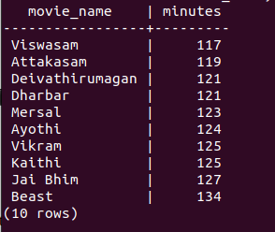

3) List down all Vijay and Ajith movies

QUERY : select Movie_name,actor from cinema where actor in('Vijay','Ajith') order by actor;
OUTPUT :

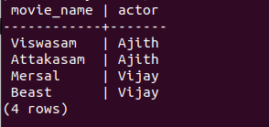

4) List down all movies where their name’s last letter is ‘i’

QUERY : select movie_name from cinema where movie_name like '%i';
OUTPUT:


5) List down all movies where actor name length is greater than 5.

QUERY : select
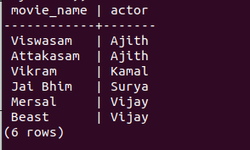
movie_name,actor from cinema where actor like '_____';
OUTPUT :

6) List down all movies where actor name length is greater than 5 and release after 2020.

QUERY : select movie_name,actor,year from cinema where actor like '_____' and year>2020 order by year;
OUTPUT :
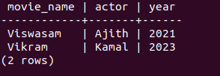

7) List down all movies where their names start with a or b or c or d.

QUERY : select movie_name from cinema where movie_name like 'A%' or movie_name like 'B%' or movie_name like 'C%' or movie_name like 'D%' order by movie_name;
OUTPUT:

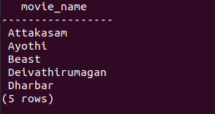

8) List down all movies acted by Vikram

QUERY : select movie_name from cinema where actor='Vikram' order by Movie_name;
OUTPUT:


9) List down all movies released in 2017 or acted by Rajini.

QUERY : select movie_name,actor,year from cinema where actor='Rajini' or year=2017 order by Movie_name;
OUTPUT :
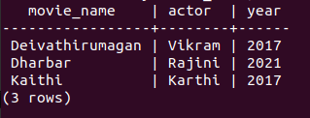

10) List down all movies released after 2019 and acted by either Sasikumar or Vijay.

QUERY : select movie_name,actor,year from cinema where actor='Vijay' or actor='Sasikumar' and year>2019 order by year;
OUTPUT :
